Hotel Reservation System

# Introduction

Reservation system try to solve the demand and supply problem between the students who wants to visit hotel to have breakfast, lunch or a dinner and hotel admin who serve the food items to students.

At one end, this system allows students to order the food at their favorite hotel at time (Morning, Noon, Evening, Night) and on other end, provides the reports to hotel admin about how many students are visiting for a subsequent sessions (breakfast, lunch, and dinner) and how many students are opt for particular items per sessions (Idli, dosa & ..).

# Problem Statement

Using the existing system, admin is not able to visualize how many students visits the hotel subsequent day (tomorrow/next session) vs quantities of food item need to prepare to serve. Due to this inefficiency admin is losing the money when excessive food goes wasted or when not able to meet the requirement of the food quantities.

# Proposed Solution

To solve above stated problem. The system should have following capabilities.

1. Authentication and Authorization: Authentication is required to prove the identity of user and Authorization is require who should access the system properties.
   1. Authentication can be achieved using following methods
      1. Social SingOn (Google, facebook ..)
      2. Mobil/email
   2. Authorization:
      1. Student: Have access to profile, booking/transaction history, account, preference and make new booking
      2. Admin: Have access to admin profile, orders per session, custom queries.
2. Account section:
   1. User profile:
      1. Profile Image, User basic info (Name, Age, ..)
      2. Settings/Preferences (College, Location, default Hotel, ..)
      3. Transaction history
3. Home section
   1. Ongoing bookings
      1. User can modify the booking within specified time.
      2. User can cancel the booking within specified time.
   2. New booking request
      1. New booking -> Calendar (Select date) -> Select slot -> Select Items (College and hotel info are fetched from user preference and user can override his default preference as well).
      2. Confirmation receipt with transaction id.
      3. Suggestions based on the experience [FUTURE]
4. Notification System:
   1. Remainder for visits
   2. Message from hotel admin, in case of any item unavailability.
   3. Promotion messages
5. Feedback [FUTURE]
   1. Feedback form where student can tell their any bad experience (anonymously). This will help hotel admin to improve further.
   2. Experience rating. Helps to understand user experience in broader way.
6. Chat [FUTURE]
   1. Students can enquire anything instantaneously. Helps to engage with the students, eventually increases the probability of student visits.
7. Admin dashboard:
   1. Hotel admin would able to see auto generated reports for each section.
   2. Should able to filter report based the food items/Students/session

# Terminologies

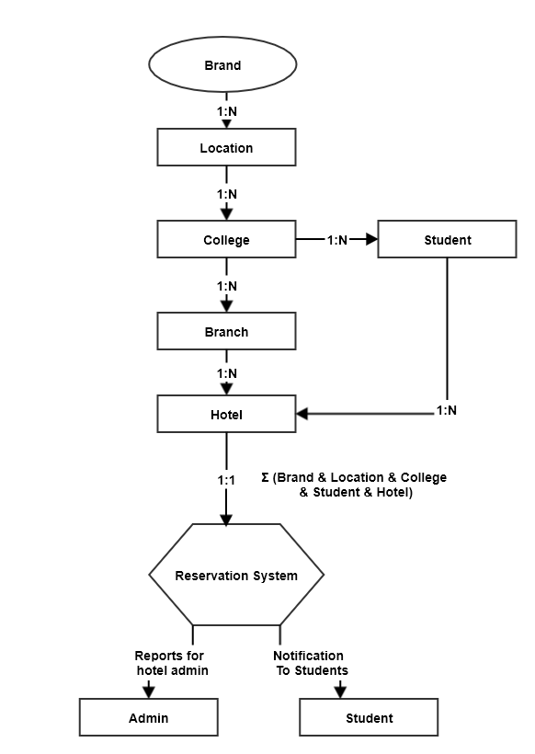

1. Brand: This system would be a generic system would not have hardcoded names for brand (company name/University name). This field can be configurable
2. Locations: College might have spread across geolocation this module will help us to have info regarding the location of the college
3. College: Within the given location there could more than one college. This module will help us info related to specific college branch.
4. Students: Comprised student info
5. Hotel Branch: With is college campus there could be many hotels. This field will help us to info related to hotel branches (east, west,..)
6. Hotel: Within given branch there could be many hotels.
7. Reservation system: This will take all the inputs mentioned above and provides the capability of bookings for students and generating the reports for admin
8. Admin: Who manages the hotel.
9. Student: Who visits the hotel.

# Architecture

